

Performance Test Results

Translink

Responsive Web Performance Test Results

Date: April 24, 2019

This report provides a summary of the results of performance tests conducted in the Responsive Web Staging environment for Translink

Prepared by:

Chris Flint

Professional Quality Assurance Ltd.

# Executive Summary

PQA conducted 6 rounds of performance testing against Translink’s new Responsive Website solution. The purpose of the testing was to assess the performance at fairly high levels.

The scope of the testing involved the creation of a new script that simulated the user activity over the course of a half hour. The average user session lasted approximately 3 minutes, and involved navigating to various pages on the website.

Measurements of the response times and throughput captured during the testing were the primary metrics used to evaluate the service. Also of interest were the server resource usage statistics – CPU and memory use.

*High Level Results*

We have 3 defined load scenarios, covered by 6 total test runs. The scenarios are:

* 500 Concurrent Users
* 1000 Concurrent Users
* 1500 Concurrent Users

Tests were run against the staging environment (new.oak.translink.ca) and the preprod environment (new.translink.ca).

We were primarily looking at “whole transactions” where we make several HTTP calls as if the user had clicked a link and waited for the page to finish loading itself, any embedded resources like CSS files or images, and made any scripted calls to over services (such as the sitenav API).

In terms of overall results, our transaction breakdown looked like:

|  |  |  |  |  |  |
| --- | --- | --- | --- | --- | --- |
| **Scenario 1.1 (500 users on Staging)** | | | | | |
| *Transaction* | *Average Response Times (Secs)* | *Total Users Started* | *Total HTTP Calls* | *Total errors* | *Error Percentage* |
| Homepage | 1.3 | 7,563 | 410,378 | 164 | 0.04% |
| Trip Planner | 1.0 |
| Next Bus | 1.1 |
| Fares | 1.0 |
| Schedules and Maps | 1.0 |
| Rider Guide | 1.0 |
| More Info | 1.0 |

|  |  |  |  |  |  |
| --- | --- | --- | --- | --- | --- |
| **Scenario 1.2 (500 users on PreProd)** | | | | | |
| *Transaction* | *Average Response Times (Secs)* | *Total Users Started* | *Total HTTP Calls* | *Total errors* | *Error Percentage* |
| Homepage | 1.3 | 6,515 | 400,633 | 68 | 0.03% |
| Trip Planner | 1.1 |
| Next Bus | 1.1 |
| Fares | 1.1 |
| Schedules and Maps | 1.1 |
| Rider Guide | 1.1 |
| More Info | 1.1 |
| Feedback | 1.4 |

|  |  |  |  |  |  |
| --- | --- | --- | --- | --- | --- |
| **Scenario 2.1 (1000 users on Staging)** | | | | | |
| *Transaction* | *Average Response Times (Secs)* | *Total Users Started* | *Total HTTP Calls* | *Total errors* | *Error Percentage* |
| Homepage | 8.6 | 10,411 | 556,935 | 365 | 0.13% |
| Trip Planner | 8.7 |
| Next Bus | 8.5 |
| Fares | 8.8 |
| Schedules and Maps | 8.6 |
| Rider Guide | 8.9 |
| More Info | 9.6 |

|  |  |  |  |  |  |
| --- | --- | --- | --- | --- | --- |
| **Scenario 2.2 (1000 users on PreProd)** | | | | | |
| *Transaction* | *Average Response Times (Secs)* | *Total Users Started* | *Total HTTP Calls* | *Total errors* | *Error Percentage* |
| Homepage | 4.7 | 10,736 | 657,133 | 328 | 0.22% |
| Trip Planner | 4.8 |
| Next Bus | 4.5 |
| Fares | 4.5 |
| Schedules and Maps | 4.5 |
| Rider Guide | 4.9 |
| More Info | 4.7 |
| Feedback | 5.8 |

|  |  |  |  |  |  |
| --- | --- | --- | --- | --- | --- |
| **Scenario 3.1 (1500 users on Staging)** | | | | | |
| *Transaction* | *Average Response Times (Secs)* | *Total Users Started* | *Total HTTP Calls* | *Total errors* | *Error Percentage* |
| Homepage | 18.8 | 10,767 | 569,054 | 1,435 | 0.50% |
| Trip Planner | 18.8 |
| Next Bus | 19.6 |
| Fares | 19.8 |
| Schedules and Maps | 19.9 |
| Rider Guide | 20.7 |
| More Info | 20.9 |

|  |  |  |  |  |  |
| --- | --- | --- | --- | --- | --- |
| **Scenario 3.2 (1500 users on PreProd)** | | | | | |
| *Transaction* | *Average Response Times (Secs)* | *Total Users Started* | *Total HTTP Calls* | *Total errors* | *Error Percentage* |
| Homepage | 12.7 | 11,585 | 699,630 | 2,618 | 0.73% |
| Trip Planner | 12.6 |
| Next Bus | 12.5 |
| Fares | 12.6 |
| Schedules and Maps | 12.9 |
| Rider Guide | 13.0 |
| More Info | 13.3 |
| Feedback | 14.4 |

The PreProd server has noticeably lower response times overall. These times should be fairly close to what we would expect an end-user to see, bearing in mind that their browsers will take slightly longer to “paint” the window.

The server resource usage didn’t change too much between the various runs.

|  |  |  |  |
| --- | --- | --- | --- |
| *Resource Statistic* | *% for 500 users* | *% for 1000 users* | *% for 1500 users* |
| CPU Usage (Staging) | 15.9% | 18.7% | 17.0% |
| Memory Usage (Staging) | 52.7% | 52.0% | 52.0% |

*Potential Issues Encountered*

The errors we encountered fell into 2 broad categories:

* The two 500 user runs briefly ran into issues where connections were reset or timed out. These errors corrected themselves after a few minutes, possibly due to an automatic server scaling process.
* The higher load runs encountered a number of HTTP 500 errors for API calls to WebBannerAlerts and SiteNav. While the WebBannerAlert didn’t provide a reason, the SiteNav calls did:
  + {"code":500,"message":"Application Error: A connection attempt failed because the connected party did not properly respond after a period of time, or established connection failed because connected host has failed to respond."}
* The overall error rate never rose above 1% of the total transactions.

# Testing Summary and Results

Performance Testing Methodology

The following Performance testing scenarios have been devised to realistically simulate users working with the new Responsive Website. These scenarios are intended to exercise the Staging and PreProd environments in order to determine the user experience when using the new site.

All scenarios will use scripts developed with Apache JMeter (an open-source performance testing tool).

Detailed descriptions of the Responsive Website load scenarios can be found below, alongside parameters for expected virtual users (derived from the test requirements and discussions with the team) and test durations.

Test Scenarios

**Scenario 1: 500 Concurrent Users**

* Users navigate through a series of pages and record the response time to get a sense of the front end user experience.
* Pages hit are:
  + Homepage
  + Trip Planner
  + Next Bus
  + Fares
  + Schedules and Maps
  + Rider Guide
  + More Information
  + Feedback (only run against PreProd)

*Expected Users*: 500 Concurrent Users

*Duration*: 30 minutes

*Environments*: new.oak.translink.ca, new.translink.ca

*Key Performance Metrics*: Response time, CPU usage, Memory usage

**Scenario 2: 1000 Concurrent Users**

* Users navigate through a series of pages and record the response time to get a sense of the front end user experience.
* Pages hit are:
  + Homepage
  + Trip Planner
  + Next Bus
  + Fares
  + Schedules and Maps
  + Rider Guide
  + More Information
  + Feedback (only run against PreProd)

*Expected Users*: 1000 Concurrent Users

*Duration*: 30 minutes

*Environments*: new.oak.translink.ca, new.translink.ca

*Key Performance Metrics*: Response time, CPU usage, Memory usage

**Scenario 3: 1500 Concurrent Users**

* Users navigate through a series of pages and record the response time to get a sense of the front end user experience.
* Pages hit are:
  + Homepage
  + Trip Planner
  + Next Bus
  + Fares
  + Schedules and Maps
  + Rider Guide
  + More Information
  + Feedback (only run against PreProd)

*Expected Users*: 1500 Concurrent Users

*Duration*: 30 minutes

*Environments*: new.oak.translink.ca, new.translink.ca

*Key Performance Metrics*: Response time, CPU usage, Memory usage

Test Results

Here can be found the performance testing results. All scenarios executed with JMeter have measured transaction statistics, as well as the following graphs:

JMeter Graphs:

* Hits per Second – displays the number of hits on the server during each second of the test. Intended to give a sense of how active a user is at any given second.
* Transactions per Second – displays the number of completed transactions during each second of the test (successful or unsuccessful). Intended to give a sense of the actual transactional load on the system at any given point
* Average Transaction Response Time – displays the average time take to get a response from the server during the load test. Intended to approximate the end-user experience as load is applied to the service.

All JMeter graphs have a granularity of 1 minute, which provides a smoother curve and has the advantage of being easier to read.

We also have a set of server graphs.

Server Graphs:

* CPU Usage (%)
* Memory Usage (%)

**Scenario 1.1 – 500 Concurrent Users (Staging)**

Tool: JMeter

JMeter Setup: 500 users, 300 seconds ramp-up, Loop “Forever”, Scheduler Enable, Scheduler Duration 1800 seconds (0.5 hours)

Server: new.oak.translink.ca

Start Time: 2019-Oct-22 06:14:41 AM (PDT)

End Time: 2019-Oct-22 06:49:35 AM (PDT)

Hits per Second:

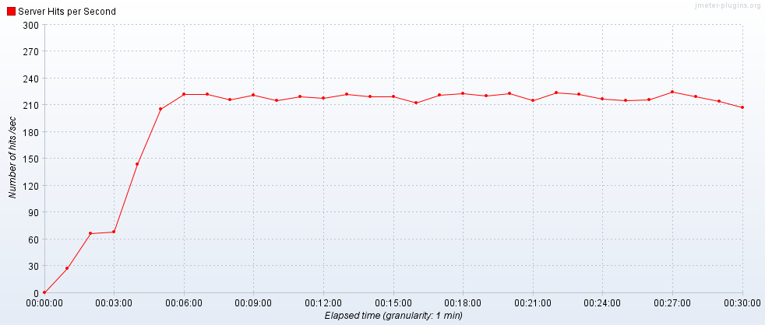

Transactions per Second:

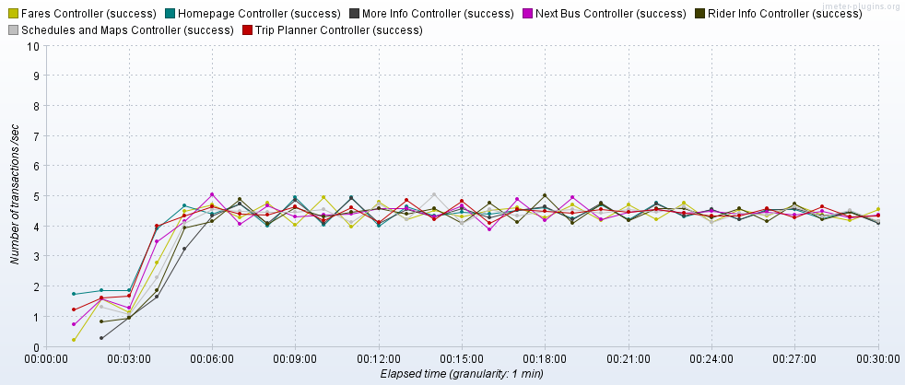

Transaction Statistics:

These are the “whole transactions” – they would be similar to a user clicking on a link and waiting for all of the elements to be displayed on their screen. If an individual element (for example, a sitenav request) takes longer, it will affect the whole transaction time. Real users may not notice a missing element, and can likely interact with the system before all elements are downloaded or displayed. The total given covers all individual HTTP calls: pages, sitenav, etc. Times are given in milliseconds.

|  |  |  |  |  |  |  |  |  |  |  |  |  |
| --- | --- | --- | --- | --- | --- | --- | --- | --- | --- | --- | --- | --- |
| Label | # Samples | Average | Median | 90% Line | 95% Line | 99% Line | Min | Max | Error % | Throughput | Received KB/sec | Sent KB/sec |
| Homepage | 7563 | 1307 | 788 | 1716 | 2746 | 13080 | 659 | 58598 | 0.34% | 4.2/sec | 3068.33 | 17.39 |
| Trip Planner | 7492 | 1048 | 717 | 1757 | 2544 | 5347 | 555 | 24918 | 0.11% | 4.2/sec | 333.83 | 5.86 |
| Next Bus | 7409 | 1068 | 722 | 1641 | 2273 | 6979 | 559 | 29870 | 0.19% | 4.2/sec | 330.73 | 6.44 |
| Fares | 7334 | 1036 | 726 | 1726 | 2432 | 4445 | 562 | 25364 | 0.06% | 4.2/sec | 445.8 | 6.82 |
| Schedules and Maps | 7239 | 1026 | 725 | 1681 | 2323 | 4176 | 559 | 34421 | 0.11% | 4.2/sec | 441.93 | 6.81 |
| Rider Guide | 7155 | 1037 | 724 | 1636 | 2255 | 4604 | 563 | 36008 | 0.17% | 4.2/sec | 434.18 | 6.77 |
| More Info | 7072 | 1028 | 727 | 1589 | 2185 | 4237 | 562 | 35322 | 0.14% | 4.2/sec | 421.9 | 6.79 |
| TOTAL | 410378 | 270 | 82 | 684 | 807 | 2078 | 8 | 58598 | 0.04% | 227.8/sec | 10778.03 | 110.93 |

Average Transaction Response Times:

The spike towards the beginning of the graph corresponds with the errors encountered in this run – we had a brief period where connections to the server were timing out.

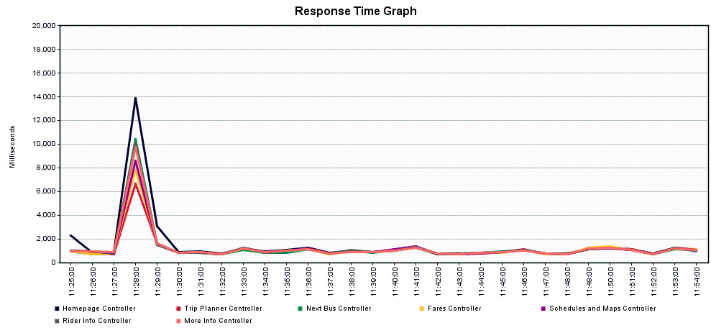

**Scenario 1.2 – 500 Concurrent Users (PreProd)**

Tool: JMeter

JMeter Setup: 500 users, 300 seconds ramp-up, Loop “Forever”, Scheduler Enable, Scheduler Duration 1800 seconds (0.5 hours)

Server: new.translink.ca

Start Time: 2019-Oct-24 07:43:49 AM (PDT)

End Time: 2019-Oct-24 08:13:44 AM (PDT)

Hits per Second:

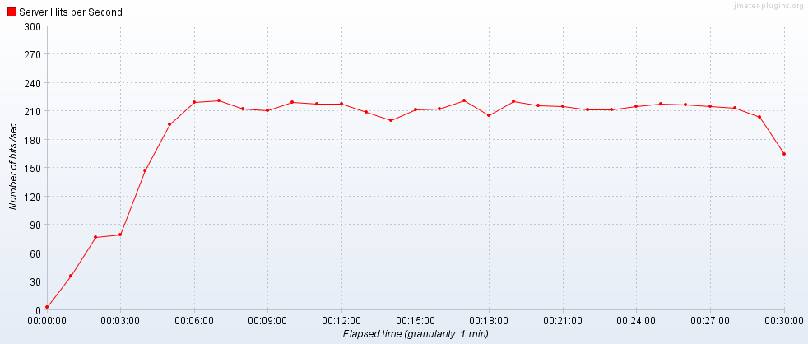

Transactions per Second:

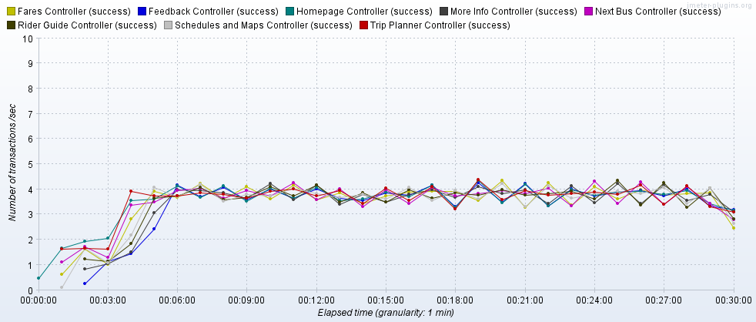

Transaction Statistics:

Like above, these are the “whole transactions”. Times are given in milliseconds.

|  |  |  |  |  |  |  |  |  |  |  |  |  |
| --- | --- | --- | --- | --- | --- | --- | --- | --- | --- | --- | --- | --- |
| Label | # Samples | Average | Median | 90% Line | 95% Line | 99% Line | Min | Max | Error % | Throughput | Received KB/sec | Sent KB/sec |
| Homepage | 6515 | 1357 | 780 | 1918 | 3017 | 13039 | 656 | 56116 | 0.31% | 3.6/sec | 1300.43 | 18.78 |
| Trip Planner | 6438 | 1148 | 728 | 1978 | 2856 | 7773 | 557 | 25378 | 0.16% | 3.6/sec | 289.06 | 6.25 |
| Next Bus | 6352 | 1119 | 726 | 1850 | 2753 | 7127 | 561 | 27063 | 0.17% | 3.6/sec | 280.81 | 6.21 |
| Fares | 6277 | 1122 | 729 | 1891 | 2789 | 7100 | 554 | 33494 | 0.16% | 3.6/sec | 325.37 | 6.55 |
| Schedules and Maps | 6221 | 1086 | 728 | 1920 | 2817 | 6716 | 563 | 26802 | 0.05% | 3.6/sec | 336.33 | 6.57 |
| Rider Guide | 6157 | 1094 | 725 | 1906 | 2758 | 6857 | 559 | 23469 | 0.07% | 3.6/sec | 330.37 | 6.54 |
| More Info | 6092 | 1093 | 726 | 1904 | 2796 | 6930 | 560 | 26803 | 0.10% | 3.6/sec | 316.89 | 6.56 |
| Feedback | 6017 | 1414 | 1066 | 2288 | 3152 | 5957 | 661 | 22523 | 0.07% | 3.6/sec | 643.96 | 5.3 |
| TOTAL | 400633 | 294 | 83 | 713 | 904 | 2512 | 12 | 56116 | 0.03% | 222.3/sec | 7420.98 | 122 |

Average Transaction Response Times:

The spike towards the beginning of the graph corresponds with the errors encountered in this run – we had a brief period where connections to the server were timing out.

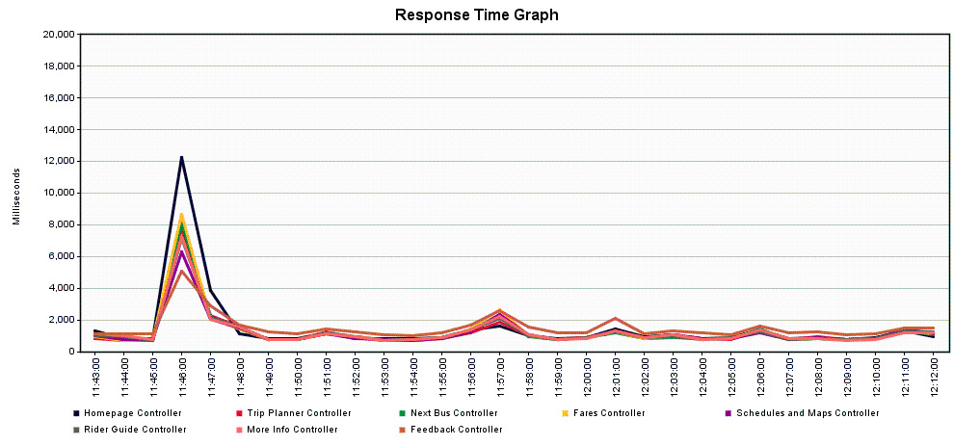

**Scenario 2.1 – 1000 Concurrent Users (Staging)**

Tool: JMeter

JMeter Setup: 500 users, 300 seconds ramp-up, Loop “Forever”, Scheduler Enable, Scheduler Duration 1800 seconds (0.5 hours), 2 running JMeter instances

Server: new.oak.translink.ca

Start Time: 2019-Oct-23 07:51:22 AM (PDT)

End Time: 2019-Oct-23 08:21:26 AM (PDT)

Hits per Second:

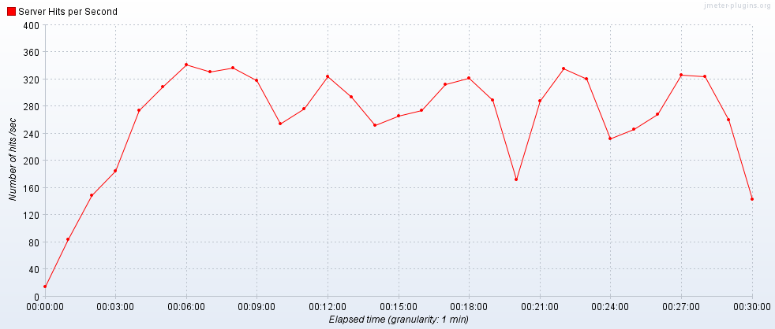

Transactions per Second:

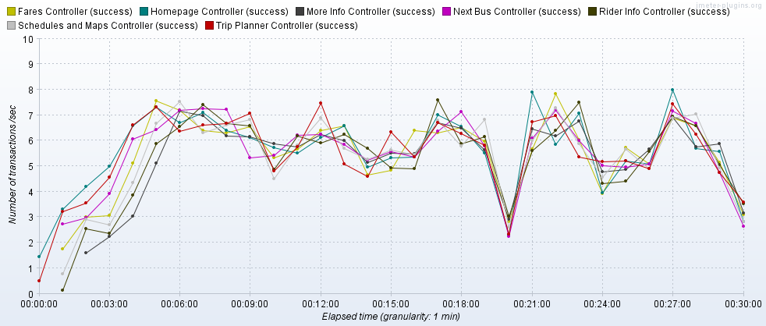

Transaction Statistics:

Like above, these are the “whole transactions”. Times are given in milliseconds.

|  |  |  |  |  |  |  |  |  |  |  |  |  |
| --- | --- | --- | --- | --- | --- | --- | --- | --- | --- | --- | --- | --- |
| Label | # Samples | Average | Median | 90% Line | 95% Line | 99% Line | Min | Max | Error % | Throughput | Received KB/sec | Sent KB/sec |
| Homepage | 10411 | 8573 | 7622 | 13784 | 17409 | 34089 | 663 | 49694 | 0.55% | 5.7/sec | 4176.13 | 23.67 |
| Trip Planner | 10233 | 8688 | 7712 | 13960 | 17420 | 35106 | 562 | 51240 | 0.54% | 5.7/sec | 450.98 | 7.92 |
| Next Bus | 10051 | 8511 | 7511 | 13641 | 17291 | 35227 | 571 | 53214 | 0.70% | 5.6/sec | 443.11 | 8.62 |
| Fares | 9911 | 8797 | 7910 | 13666 | 17578 | 36758 | 560 | 53378 | 0.34% | 5.6/sec | 594.82 | 9.1 |
| Schedules and Maps | 9768 | 8625 | 7821 | 13443 | 16543 | 31945 | 576 | 49811 | 0.41% | 5.6/sec | 589.89 | 9.09 |
| Rider Guide | 9624 | 8914 | 7902 | 13891 | 18311 | 40330 | 578 | 52615 | 0.54% | 5.6/sec | 577.37 | 9 |
| More Info | 9471 | 9076 | 8022 | 14088 | 18466 | 37359 | 594 | 52805 | 0.60% | 5.5/sec | 558.25 | 8.99 |
| TOTAL | 556935 | 2183 | 1147 | 5465 | 9453 | 16964 | 8 | 53378 | 0.13% | 305.7/sec | 14579.69 | 149.23 |

Average Transaction Response Times:

The spike towards the end of the graph corresponds with the errors encountered in this run – we had a brief period where the webBannerAlerts call was encountering HTTP 500 errors, possibly due to sockets being exhausted with our limited IP pool.

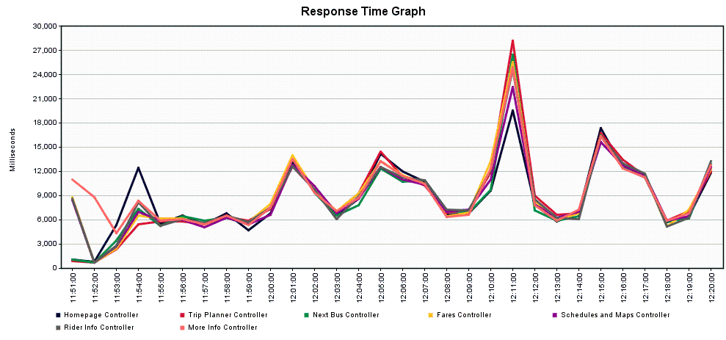

**Scenario 2.2 – 1000 Concurrent Users (PreProd)**

Tool: JMeter

JMeter Setup: 500 users, 300 seconds ramp-up, Loop “Forever”, Scheduler Enable, Scheduler Duration 1800 seconds (0.5 hours), 2 running JMeter instances

Server: new.translink.ca

Start Time: 2019-Oct-24 09:19:58 AM (PDT)

End Time: 2019-Oct-24 09:50:28 AM (PDT)

Hits per Second:

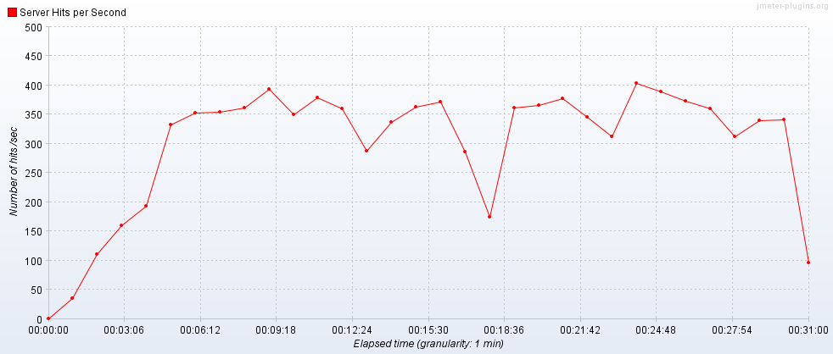

Transactions per Second:

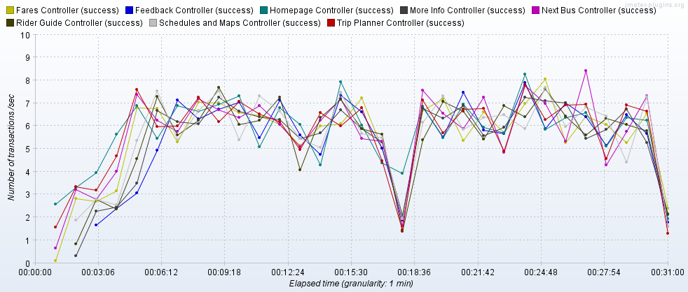

Transaction Statistics:

Like above, these are the “whole transactions”. Times are given in milliseconds.

|  |  |  |  |  |  |  |  |  |  |  |  |  |
| --- | --- | --- | --- | --- | --- | --- | --- | --- | --- | --- | --- | --- |
| Label | # Samples | Average | Median | 90% Line | 95% Line | 99% Line | Min | Max | Error % | Throughput | Received KB/sec | Sent KB/sec |
| Homepage | 10736 | 4658 | 3552 | 8917 | 10778 | 26400 | 669 | 46365 | 0.52% | 5.9/sec | 2111.82 | 30.36 |
| Trip Planner | 10621 | 4772 | 4031 | 8444 | 10091 | 30944 | 575 | 42453 | 1.32% | 5.9/sec | 470.01 | 10.13 |
| Next Bus | 10489 | 4495 | 3787 | 8431 | 9878 | 17835 | 572 | 42939 | 0.49% | 5.9/sec | 457.19 | 10.09 |
| Fares | 10353 | 4540 | 3783 | 8360 | 10006 | 28982 | 567 | 45044 | 0.82% | 5.8/sec | 528.63 | 10.61 |
| Schedules and Maps | 10205 | 4508 | 3795 | 8376 | 9852 | 29069 | 572 | 42687 | 0.85% | 5.8/sec | 543.44 | 10.59 |
| Rider Guide | 10051 | 4885 | 4122 | 8573 | 9894 | 31444 | 565 | 42935 | 1.26% | 5.8/sec | 531.97 | 10.51 |
| More Info | 9914 | 4669 | 3893 | 8370 | 10009 | 31079 | 582 | 42298 | 0.95% | 5.8/sec | 508.73 | 10.5 |
| Feedback | 9740 | 5782 | 4933 | 10529 | 12569 | 29059 | 756 | 43527 | 0.90% | 5.7/sec | 1029.23 | 8.45 |
| TOTAL | 657133 | 1194 | 589 | 2343 | 5229 | 9948 | 13 | 46365 | 0.22% | 359.2/sec | 11992 | 196.74 |

Average Transaction Response Times:

The spike towards the middle of the graph corresponds with the errors encountered in this run – we had a brief period where the webBannerAlerts call was encountering HTTP 500 errors, possibly due to sockets being exhausted with our limited IP pool.

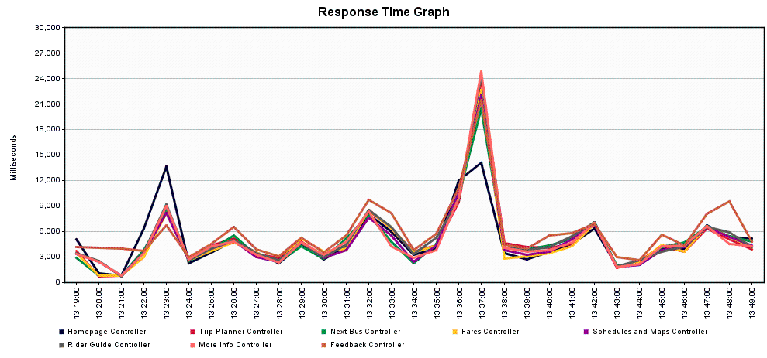

**Scenario 3.1 – 1500 Concurrent Users (Staging)**

Tool: JMeter

JMeter Setup: 500 users, 300 seconds ramp-up, Loop “Forever”, Scheduler Enable, Scheduler Duration 1800 seconds (0.5 hours), 3 running JMeter instances

Server: new.oak.translink.ca

Start Time: 2019-Oct-23 09:21:32 AM (PDT)

End Time: 2019-Oct-23 09:51:44 AM (PDT)

Hits per Second:

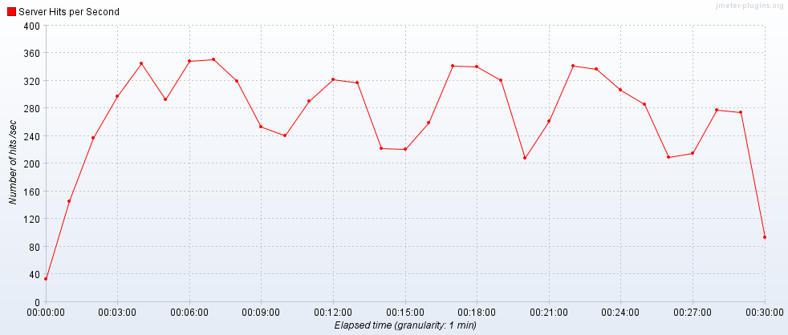

Transactions per Second:

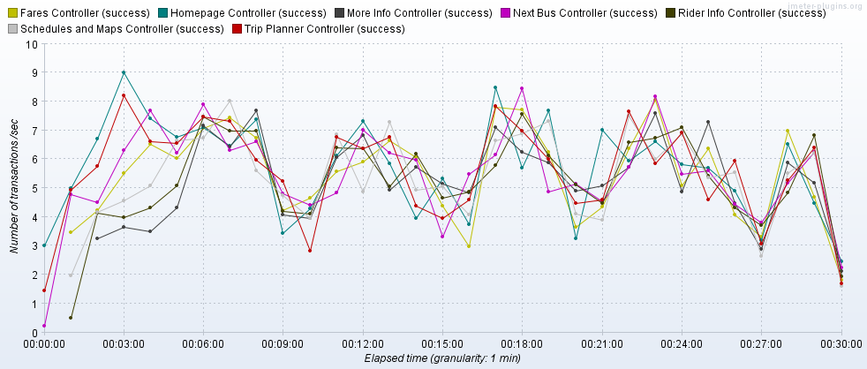

Transaction Statistics:

Like above, these are the “whole transactions”. Times are given in milliseconds.

|  |  |  |  |  |  |  |  |  |  |  |  |  |
| --- | --- | --- | --- | --- | --- | --- | --- | --- | --- | --- | --- | --- |
| Label | # Samples | Average | Median | 90% Line | 95% Line | 99% Line | Min | Max | Error % | Throughput | Received KB/sec | Sent KB/sec |
| Homepage | 10767 | 18780 | 17629 | 27945 | 36091 | 62165 | 674 | 86433 | 1.47% | 5.9/sec | 4301.61 | 24.38 |
| Trip Planner | 10553 | 18805 | 17434 | 27741 | 39090 | 64337 | 570 | 89082 | 1.89% | 5.8/sec | 463.28 | 8.14 |
| Next Bus | 10362 | 19603 | 17789 | 28957 | 40408 | 65606 | 573 | 88320 | 2.22% | 5.8/sec | 455.46 | 8.86 |
| Fares | 10076 | 19812 | 18024 | 29021 | 38870 | 65250 | 576 | 86052 | 2.24% | 5.7/sec | 602.64 | 9.23 |
| Schedules and Maps | 9858 | 19867 | 18137 | 28672 | 38899 | 64879 | 555 | 85056 | 2.06% | 5.6/sec | 593.55 | 9.15 |
| Rider Guide | 9683 | 20706 | 18460 | 30470 | 45015 | 69501 | 576 | 86315 | 2.10% | 5.6/sec | 579.63 | 9.04 |
| More Info | 9397 | 20934 | 18608 | 29967 | 43515 | 67830 | 600 | 84534 | 2.30% | 5.5/sec | 552.5 | 8.89 |
| TOTAL | 569054 | 4946 | 2613 | 14943 | 21101 | 40217 | 8 | 89082 | 0.50% | 311.0/sec | 14929.12 | 151.99 |

Average Transaction Response Times:

The spikes in the graph corresponds with the errors encountered in this run – we had 4 brief periods where the webBannerAlerts call was encountering HTTP 500 errors, possibly due to sockets being exhausted with our limited IP pool.

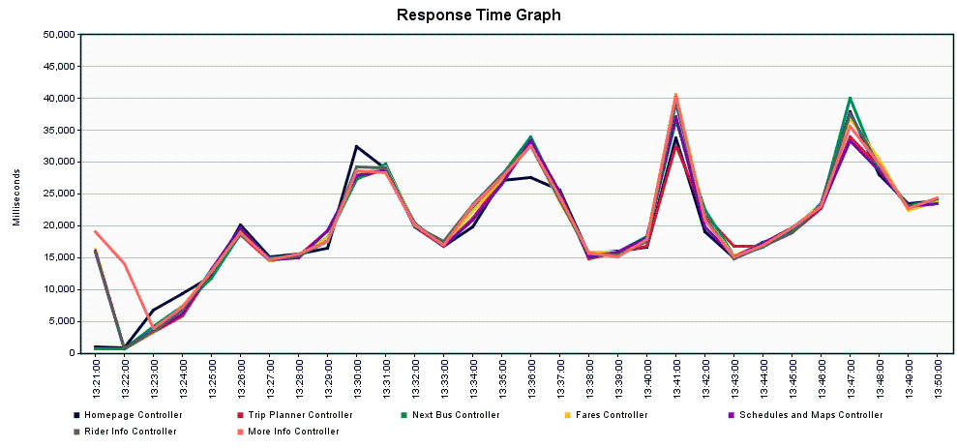

**Scenario 3.2 – 1500 Concurrent Users (PreProd)**

Tool: JMeter

JMeter Setup: 500 users, 300 seconds ramp-up, Loop “Forever”, Scheduler Enable, Scheduler Duration 1800 seconds (0.5 hours), 3 running JMeter instances

Server: new.translink.ca

Start Time: 2019-Oct-24 10:40:26 AM (PDT)

End Time: 2019-Oct-24 11:10:46 AM (PDT)

Hits per Second:

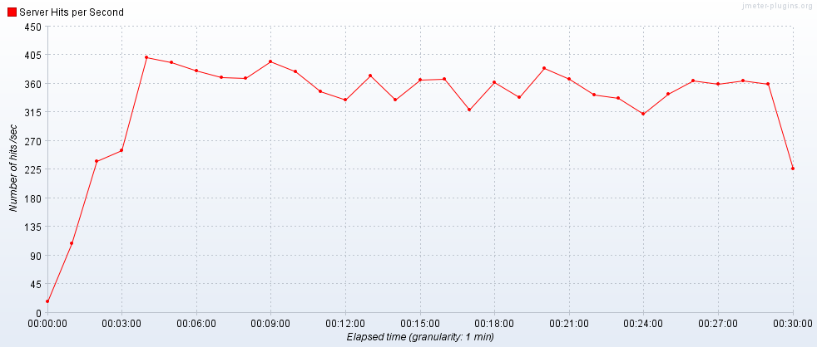

Transactions per Second:

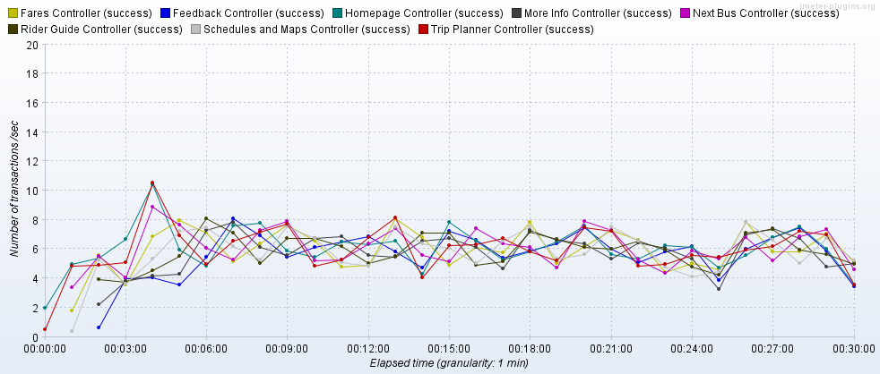

Transaction Statistics:

Like above, these are the “whole transactions”. Times are given in milliseconds.

|  |  |  |  |  |  |  |  |  |  |  |  |  |
| --- | --- | --- | --- | --- | --- | --- | --- | --- | --- | --- | --- | --- |
| Label | # Samples | Average | Median | 90% Line | 95% Line | 99% Line | Min | Max | Error % | Throughput | Received KB/sec | Sent KB/sec |
| Homepage | 11585 | 12675 | 12808 | 18070 | 21006 | 36979 | 675 | 60515 | 2.49% | 6.4/sec | 2292.29 | 32.62 |
| Trip Planner | 11425 | 12640 | 12651 | 17965 | 20974 | 36994 | 565 | 58616 | 3.00% | 6.3/sec | 507.62 | 10.89 |
| Next Bus | 11265 | 12474 | 12468 | 17807 | 20510 | 35784 | 570 | 59175 | 2.49% | 6.3/sec | 492.55 | 10.81 |
| Fares | 11062 | 12570 | 12582 | 17617 | 20418 | 35916 | 576 | 59981 | 2.78% | 6.3/sec | 566.6 | 11.32 |
| Schedules and Maps | 10835 | 12946 | 12655 | 18088 | 21109 | 36411 | 569 | 58394 | 3.46% | 6.2/sec | 581.67 | 11.28 |
| Rider Guide | 10603 | 13028 | 12767 | 17844 | 20632 | 37361 | 587 | 58207 | 2.94% | 6.2/sec | 565.47 | 11.11 |
| More Info | 10393 | 13326 | 12906 | 17999 | 20785 | 36745 | 592 | 58869 | 2.93% | 6.1/sec | 536.74 | 11.02 |
| Feedback | 10149 | 14423 | 13942 | 19268 | 22069 | 38585 | 757 | 59490 | 2.92% | 6.0/sec | 1078.76 | 8.82 |
| TOTAL | 699630 | 3245 | 1945 | 10496 | 13938 | 21011 | 13 | 60515 | 0.73% | 384.5/sec | 12863.18 | 209.78 |

Average Transaction Response Times:

The spike towards the end of the graph corresponds with the errors encountered in this run – we had a brief period where the webBannerAlerts and sitenav calls were encountering HTTP 500 errors, possibly due to sockets being exhausted with our limited IP pool.

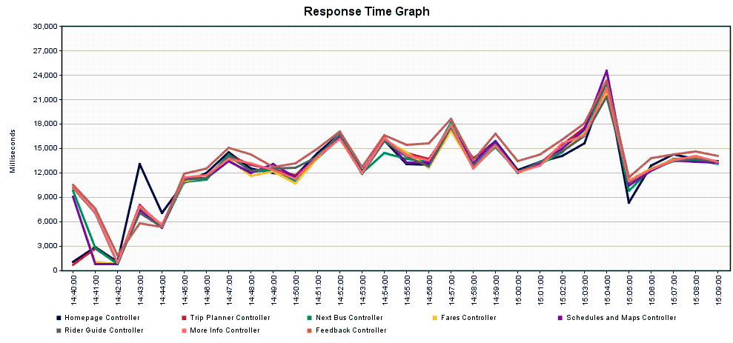

Server Graphs

Overall, the server usage didn’t really move too much, suggesting that the load was easily taken up, regardless of the level applied.

Scenario 1.1:

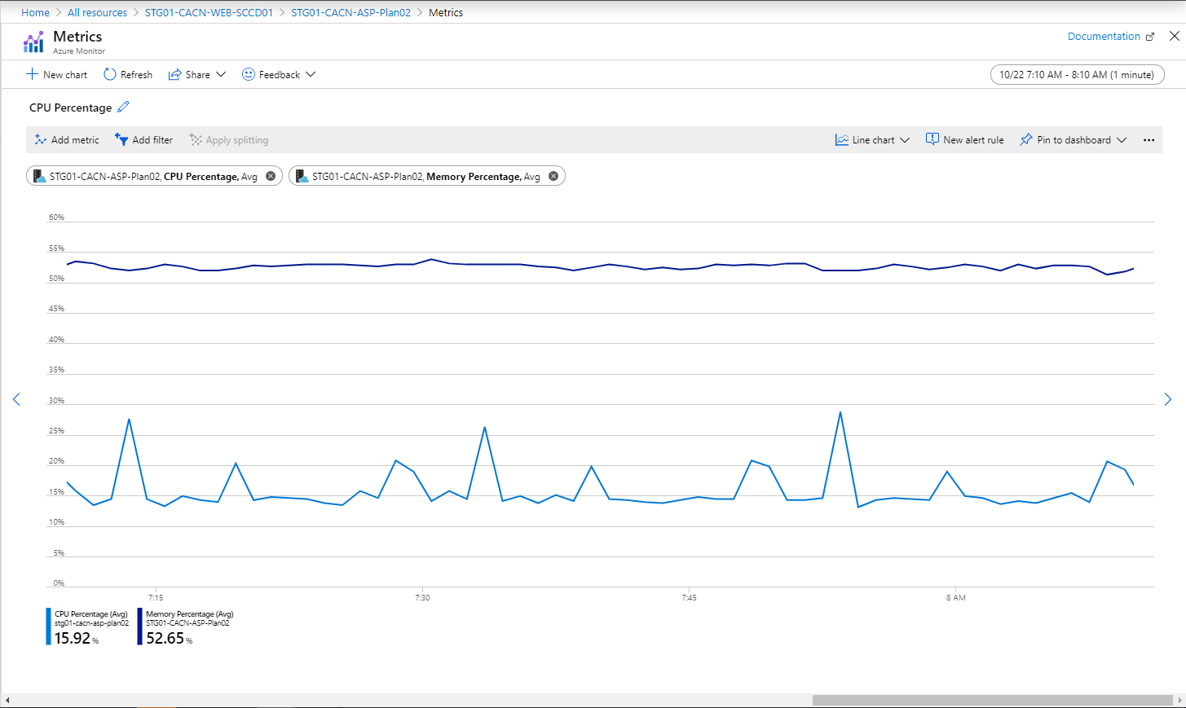

Scenario 2.1:

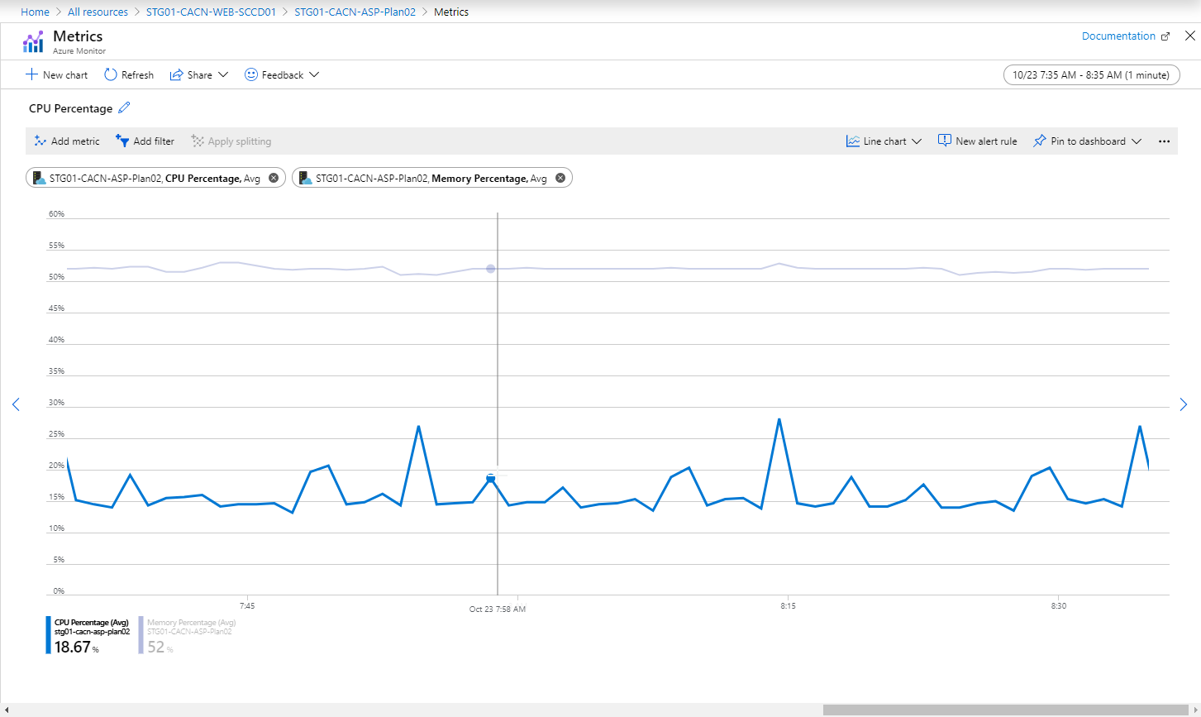

Scenario 3.1:

